Nepal College of Information Technology
Assessment
Fall 2011
Program : BE CE/IT Time : 3 hrs
Semester : Fall (I) FM : 100
Subject : Basic Electrical Engineering PM : 50

- Candidates are requested to give their answer as far as practicable in their own words.
- The figure in the margin indicates the full marks
- Attempt ALL question
1. a) Find the Current through 5 Ω resistor using Maxwell’s loop method: 8
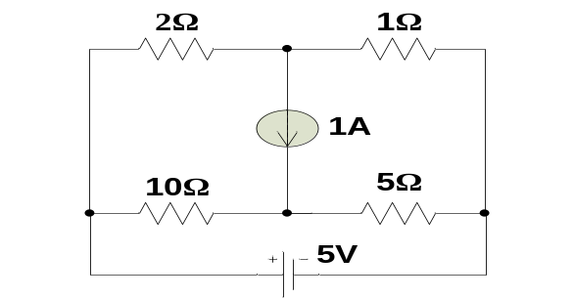
b) Find the Value of R_{L} so that maximum power is transferred across it. Also calculate the value of its Maximum power. 7
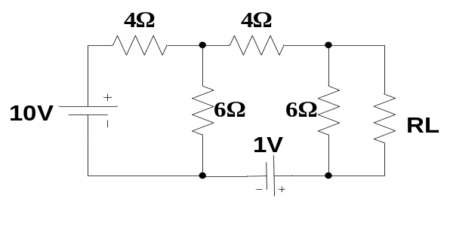
2. a) Use Nodal analysis to find value of Vx (drop across 1Ω) in the circuit below. 8
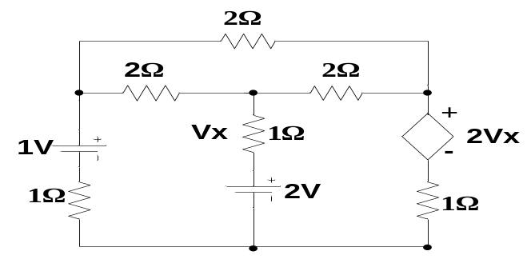
b) Find the current through 4Ω resistor using superposition theorem. 7
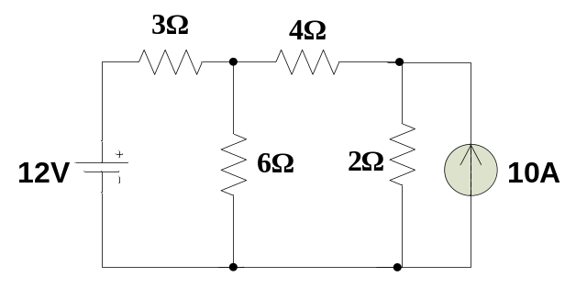
3. a) Find the Rms and Average value of the following waveform. 8
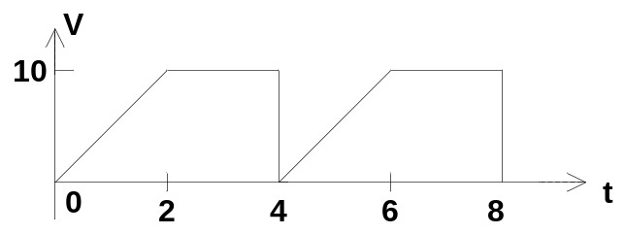
b) Show that is 3 phase star connection the line voltage is √3 times the phase voltage. Also specify the active power. 7
4. a) Describe the resonance in parallel R-L-C circuit. 7
b) An R-L circuit with R=10Ω and L=0.3 mH is connected to a v(t) = 100 sin 314t 8
i) Find Instantaneous current
ii) Draw vector diagram
iii) Calculate the value of capacitance to be connected in series to obtain minimum impedance of the circuit.
5. a) What are the losses in the transformer? Derive the condition of maximum efficiency for a transformer. 7
b) A 10 KVA, 220/110 V, 50 Hz, single phase transformer has following readings: 8

O. C Test: | 250 V, | 1 A, | 120 W | (on L-V side)
S. C Test: | 12 V, | 8 A, | 80W | (on H-V-side)
Obtain circuit parameters and draw equivalent circuit referred to primary side.
6. a) Describe Armature Reaction and Commutation in the dc generator? 7
b) A 250 V dc shunt motor has armature resistance of 0.25 Ω, on increasing its load the armature current is 50 A and its speed is 750 rpm. If the flux of the motor is reduced by 10% without changing the load torque, obtain the new speed of the motor. 8
7. Write short notes on: (Any Two) 5*2=10
a) Hysteresis loss and Eddy current loss
b) Two wattmeter method
c) Ideal voltage and Current sources.

